Business Project Awareness, Safety & Sustainability B49BC

Date Submitted: 03/12/2018

Word Count: 3833

FILTRATION OF WATER USING A SLOW SAND FILTER IN TAMIL NADU

Group 55:

Andrew Hannigan – H00221889

Blair McGilvray – H00241230

Musaab Mohamed – H00247544

Bethany Mulliner – H00238016

Alex Swift – H00250771

Supervisors: Duncan Fraser, Lara Severne

Course Director: Reza Mohammadi

**Abstract**

The 2018-19 Engineers Without Border Engineering for People Design Challenge asked for entries to propose engineering innovations and interventions to make a difference in order to improve people’s quality of life in Tamil Nadu, India. Seven challenge areas were available to select from to tackle. We chose water due to our believe that access to clean, safe drinking water is a basic human need, and as such tackling this issue should therefore take precedence. The vast majority of Tamil Nadu’s roughly 37 million people living in rural areas [1] rely on unmanaged, poor quality sources of groundwater, leading to issues regarding both water quantity and water quality. [2]

Tamil Nadu has a vast number of rivers across the region currently used mainly for the irrigation of crops, however the water quality is too poor for other uses, thus making it unsafe to drink. Where clean water is available, the proper capture and storage of this drinkable water is not properly utilised. We plan to address this issue by providing a way of obtaining cheap, safe drinking water, in order to vastly improve people’s quality of life.

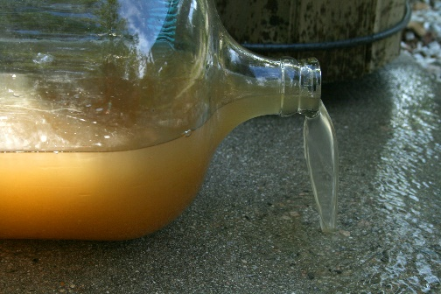

The vast majority of Tamil Nadu’s 37 million rural residents do not have access to clean drinking water. [11]

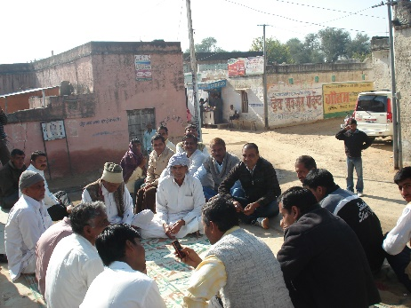

Involving the local communities in the project is a good way to increase enthusiasm for it. [12]

|  |  |
| --- | --- |
| Topic | Page Number |
| Introduction | 4 |
| Design Features | 5 |
| Overview | 5 |
| Maintenance | 6 |
| Advantages and Disadvantages | 6 |
| Design Diagram | 6 |
| Implementation and Sustainability | 7 |
| Process Diagram | 8 |
| Gantt Chart | 8 |
| Design Analysis | 9 |
| Costing | 9 |
| Funding | 10 |
| QoL Improvements | 11 |
| Health & Safety | 11 |
| Risk Matrix | 12 |
| SWOT Diagram | 13 |
| Prospective Design Improvements | 14 |
| Conclusion | 14 |
| References | 15 |
| Appendix I: Plan of Work | 17 |
| Appendix II: Minutes | 18 |
| Appendix III: Peer Review | 30 |
| Appendix IV: Supervisor Review | 32 |
| Appendix V: Declaration | 34 |

**Contents**

**Introduction**

To tackle the issues mentioned in the introduction, we have proposed the creation and usage of a slow sand filter, which shall utilise river water and rain to provide a sustainable source of clean drinking water. By utilising the local geography, consisting of many rivers and often steep hillsides, water can flow using gravity alone onto a sand filter consisting of several layers of different types of sand capable of removing dangerously high levels of minerals and metals content. In areas that are flatter, water can be collected by hand to be put into the filter. Such a filter also utilises a biological layer of bacteria, which will grow naturally on the top of the sand and will remove harmful levels of microorganisms in the water.

Due to the simplicity of its design, our slow sand filter is very cheap and affordable for the communities in which it would be utilised. The design also has minimal negative environmental effects and is very sustainable.

By educating the local population on its design and maintenance, and also on proper water storage and rationing techniques, such a design would also be easily maintained by the local community. By educating and directly involving the community in the upkeep of the project, the positive effects will be twofold. Firstly, the community will be far more enthusiastic about a project that they are directly involved in, and secondly, any expensive costs of maintenance by a third party are completely negated.

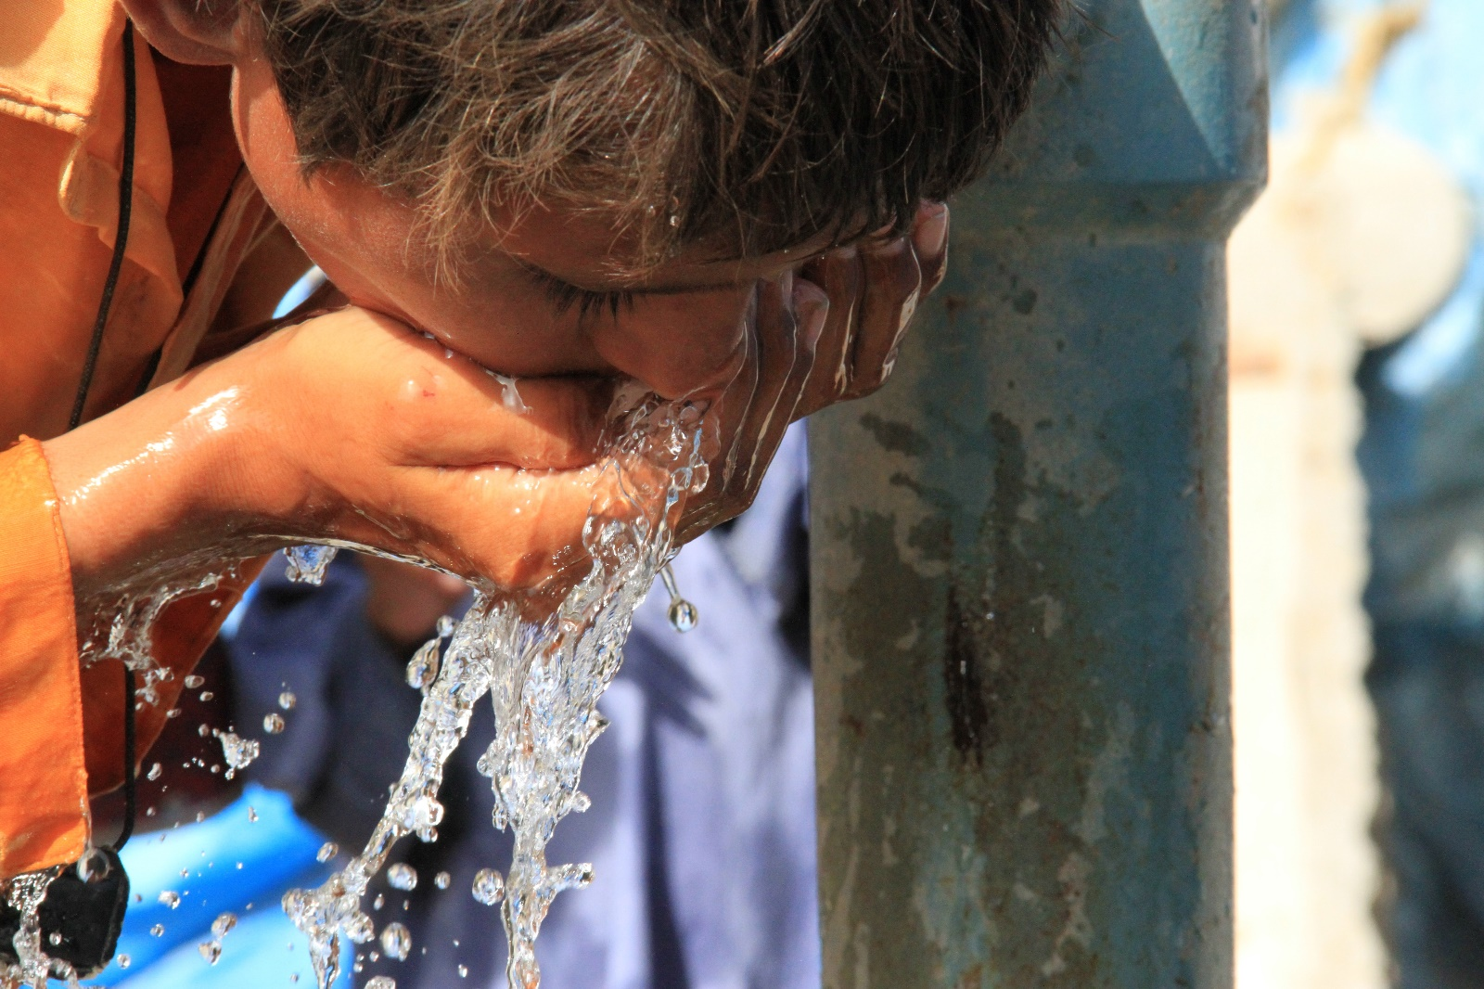

By providing a source of clean drinking water to the residents of Tamil Nadu, their quality of life will be vastly improved. [14]

**Design Features**

**Overview**

For the project to be a success we need to find a way to provide clean drinking water to the people of Tamil Nadu at as low a cost as possible. We considered different filter systems for this, but most were relatively complicated or required electricity in the filtration process. The design we ended on is a slow sand filter. It is very cheap to produce, does not require too much maintenance, is very simple to use, produces very little waste, and can be made of recycled materials.

Table 1: Decision Matrix

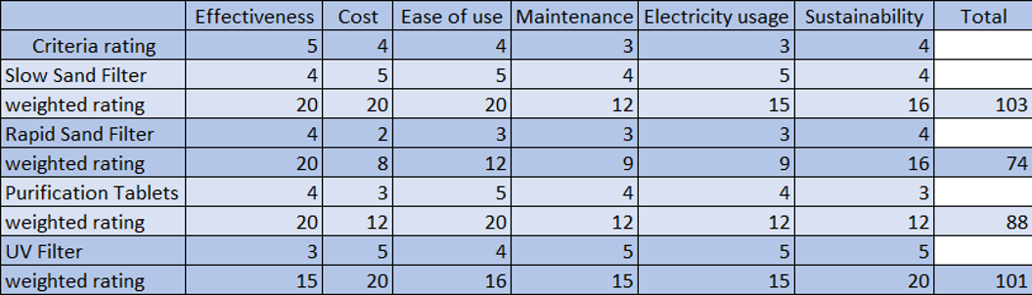

Slow sand filters are used in water purification for treating raw water to produce a potable product. They are typically 1 to 2 metres deep, can be rectangular or cylindrical in cross section and are used primarily to treat surface water. The length and breadth of the tanks are determined by the flow rate desired by the filters, which typically have a loading rate of 200 to 400 litres per hour per square metre (or 0.2 to 0.4 cubic metres per square metre per hour).

The proposed design of the slow sand filter is to be a cylindrical cross section with a diameter of 0.46m and a depth of 1m. Each filter has been designed to process 50L of water per hour. A diagram of the design can be seen on the following page.

Slow sand filters differ from all other filters used to treat drinking water in that they work by using a complex biological film that grows naturally on the surface of the sand. The sand itself does not perform any filtration function but simply acts as a substrate, unlike its counterparts for UV and pressurized treatments.

Slow sand filters work through the formation of a gelatinous layer (or biofilm) called the hypogeal layer in the top few millimetres of the fine sand layer. The hypogeal layer is formed in the first 10 - 15 days of operationand consists of bacteria, fungi, protozoa, rotifera and a range of aquatic insect larvae. As an epigeal biofilm ages, more algae tend to develop, and larger aquatic organisms may be present. The surface biofilm is the layer that provides the effective purification in potable water treatment, the underlying sand providing the support medium for this biological treatment layer. As water passes through the hypogeal layer, particles of foreign matter are trapped in the mucilaginous matrix and soluble organic material is adsorbed. The contaminants are metabolised by the bacteria, fungi and protozoa. The water produced from a slow sand filter is of excellent quality with 90-99% bacterial cell count reduction.

**Maintenance**

Slow sand filters slowly lose their performance as the biofilm thickens and thereby reduces the rate of flow through the filter. Eventually, it is necessary to refurbish the filter. Two methods are commonly used to do this. In the first, the top few millimetres of fine sand are scraped off to expose a new layer of clean sand. Water is then decanted back into the filter and re-circulated for a few hours to allow a new biofilm to develop. The filter is then filled to full volume and brought back into service. The second method, sometimes called wet harrowing, involves lowering the water level to just above the hypogeal layer, stirring the sand; thus, precipitating any solids held in that layer and allowing the remaining water to wash through the sand. The filter column is then filled to full capacity and brought back into service. Wet harrowing can allow the filter to be brought back into service more quickly. Complete replacement of the filter is necessary after 20 years of operation.

**Advantages and Disadvantages**

The slow sand filter poses several very important qualities. The first being that no mechanical power is required for the filter to produce decontaminated water. Therefore, the actual running cost of the filter is almost negligible; the periodic maintenance of the filter is the only factor which will contribute to the running cost. Secondly, the filtration of decontaminated water does not require any environmentally harmful chemicals or a chemical process. The purification and filtration processes are completely biological and therefore non-harmful to the environment

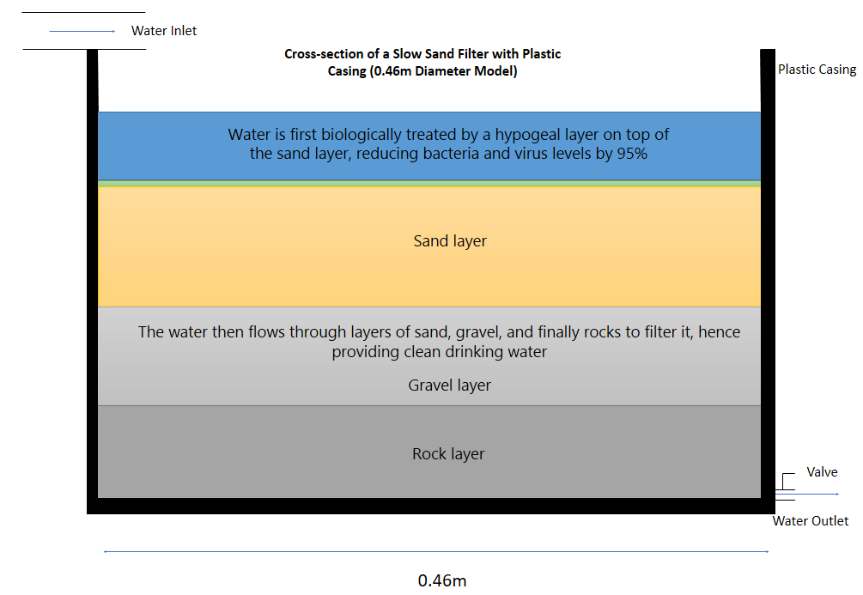However, the slow sand filter also displays some disadvantages. The main being that the filter relies solely on rainwater as the water input. Hence, if there were to be a drought then there would be a lack of water available to filter. Therefore, a storage tank could be implemented for the locals to store clean water in the case of a drought.

Figure 1: Our proposed design

**Implementation and Sustainability**

Living a healthy life depends on many factors and one of these factors is a source of clean drinking water water. Also, having sustainable clean water has been a goal of many countries for years. The people of Tamil Nadu state need a source that will provide them with sustainable clean water.

As a group, we came up with an idea of providing filtered water for the people in the rural area of Tamil Nadu. The main reason we decided on filtering water using a slow-sand filter is that it will need minimum maintenance. This means that the citizens will not have to spend large amounts of funds and energy on maintenance.

In order for this project to succeed and to be sustainable for as long as it is needed to be, three factors should be available as support. The financial, organizational, and community sustainability are very important to support this project. The availability of funds is critical when it comes to building or inventing any project; however, for this project, we only need to rely on a minimal amount of funds, since the filter will not require much maintenance because we can mainly depend on community upkeep.

According to an article on financing sustainable water: “Through improved financial planning, water utilities can better manage revenue instability, meet short- and long-term financial objectives and incorporate water use efficiency programs as an important means toward improving customer water service.” This explains that financial planning will better manage the sustainability of water which is why we depend on decidedly fewer funds for this project.

Secondly, organizational sustainability is a significant factor. Knowing how often the filter needs to change and the demonstration of how it should be used will determine how long the project will last. Educating people about this project will be helpful because if everyone in the community is knowledgeable about this project, then there will be less maintenance required.

Lastly, this project will be sustainable if the community as a whole cooperate. The cooperation of everyone can lead to outstanding outcomes. For example, if everyone becomes committed to a role such as how much water to consume daily, the community will witness very lasting results.

Also, educating the community about the type of help that they can provide for this project will make the job of engineers simple since everyone will be on the same page. [11]

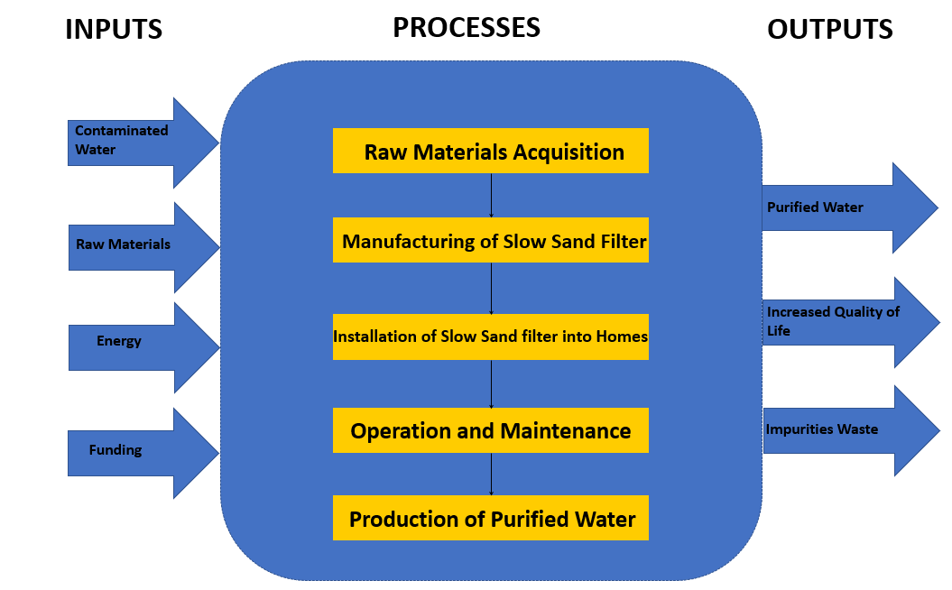

Figure 2a: Process Implementation Gantt Chart

Figure 2: Process Diagram

**Design Analysis**

**Costing**

Similar projects have found the price for the raw materials and manufacturing of a single filter of similar size and usage to be around £30. [3] Including transportation and installation of the manufactured filter, the cost increases to £75. [4] The Tamil Nadu state aims for a water supply of 55 litres per person per day [5], so the number of filters required must accommodate this. Each filter is expected to be able to process around 50 litres each hour, so running a single filter for 12 hours a day is enough to provide clean water for 10 people. As the cleaning process is lengthy, more filters are required to ensure filtering can continue while some filters are being cleaned. Doubling the number of filters is sufficient for this. If 2 filters, costing £75 each, used in alternating shifts, are enough to provide clean water for 10 people, the cost of the filters that would provide clean water for a single person for at least 10 years is £15. For a village of 2,000 people approximately 400 filters would be required, costing a total of £30,000.

For the project to operate, more costs are involved. If the filter body is made from recycled plastic, the cost of the mould and plastic injection machine must be included. The rent and bills of a warehouse to produce and store the filters in are also required, as well as the cost of a truck to transport materials and finished filters. The mould and injection machine would likely cost at least £10,000, [6] and the truck around £20,000. Warehouse rent would heavily depend on its size and location but would likely be at least £2,000 per year.

Further costs include wages for employees and training residents in how to clean and safely operate the filters. Employee yearly wages would be around £1,500 per employee.

To decrease costs, as much of the manufacturing should be done in Tamil Nadu as possible. This will allow money to be saved by reducing the cost of transporting finished filters, buying raw materials, and paying wages.

The total cost of a trial run, aiming to provide enough filters for a village of 2,000 people over a 1-year period with 5 employees, would be at least £72,000.

Table 2 – Initial project costs

|  |  |  |
| --- | --- | --- |
| Initial project costs |  | Cost |
| Plastic injection machine and mould |  | £10,000+ |
| Truck |  | £20,000 |
| Total |  | £30,000+ |

Table 3 – Costs per filter

|  |  |  |
| --- | --- | --- |
| Costs per filter | Cost per filter | Cost of 400 filters |
| Raw materials and manufacturing | £30 | £12,000 |
| Transportation, installation, and other costs | £45 | £18,000 |
| Total | £75 | £30,000 |

Table 4 – Other costs

|  |  |
| --- | --- |
| Other costs | Cost (1 year) |
| Wages, single person | £1,500 |
| Warehouse rent | £2,000+ |

**Funding**

The main five types of funding available are bank loans, government agency funding, local resident funding, charity, and crowdfunding.

If the project is not expected to be profitable, a bank loan is unlikely to be available directly. Whether the project is profitable or not would largely depend on the price residents are willing to pay to have their water filtered. The price of 1,000 litres of water in rural areas is Rs. 3.00 [7], or around £0.03. With both the cost of water and incomes in general being low, it is unlikely residents would be willing to pay a much greater amount for water to be cleaned, which makes the profitability of the project a concern. If the project is found to not be profitable then one option would be to achieve charitable status, or partner with an existing charity, and use donation money to partially fund the project.

Previous projects have found that, despite low income, residents and village governments are also willing to help pay for projects, as the quality of life improvements are substantial. The estimated contribution from village governments is 10% of the initial capital cost, and the residents providing a further 15% as well as all costs of filter maintenance. [8] If these results could be replicated then, even without the costs of the project being paid outright, the funding required from other sources would decrease drastically, making the project a lot more feasible.

A close up of a logo

Description generated with very high confidence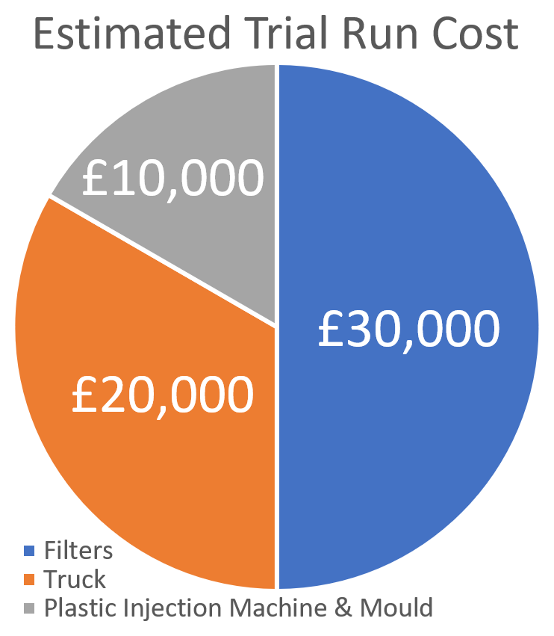Large investments, often of around £100 million, [8] have been made in other water-based projects in India in recent years, so while the project may not be profitable, if such an investment was made it would be enough to implement the project in many villages, impacting the lives of thousands of people. In order to prove the project feasible a trial run could be done on a smaller scale, such as a single village, funded through a bank loan or from charitable donations.

Figure 4: Estimated cost per filter pie chart

Figure 3: Estimated trial run cost pie chart

If funding from other sources is not sufficient, another option would be to use crowdfunding through websites such as Kickstarter or JustGiving. This would not be ideal however as a large proportion of crowdfunding campaigns, around 63% of Kickstarter [9] projects, fail to meet the required target.

The best choice for funding would be using a mix of sources, relying on residents and local governments for the filter maintenance and operation costs as well as 25% of the initial capital costs, and on donations through charity or large investments for the remaining initial capital, and for buying equipment and paying other running costs.

From the estimated trial run cost of £72,000, if residents and local governments fund 25% of this and cover maintenance costs, the project would require at least £54,000 from other sources in order to go ahead. Any further money raised could be reinvested into the project, either improving the filter design or producing more to be used in other villages.

**Quality of Life Improvements as a Result of Our Product**

The economic outlook of a city can either become successful or unsuccessful depending on different factors. The availability of filtered water can significantly improve the economy of Tamil Nadu city in so many ways. Through the availability of clean water, the city will witness a productivity growth which can be obtained through the decrease in the usage of electricity and the cost of water transportation. Ground gravitational force is used in the slow sand filter to generate water and thus there is no electricity consumption. Because electricity is also an issue that the people of Tamil Nadu state are facing, giving them the option to use less electricity in their day to day lives will save them economically and giving them continuous water supply by storage water. Also, transportation of water needs many funds. It is costly to transport water because these funds that are going towards transportation that can be used to solve other economic issues that the city might face in the future. Hence requiring fewer funds to spend on transportation will undoubtedly be helpful to the state economically in the long run.

Moreover, Tushaar Shah in his article [10] Where India’s water economy stands points out that “The development of water infrastructure should be seen as closely linked to the improvement of the human development index (HDI)…There is no correlation between water availability and its quality or accessibility. Countries with a low per capita income such as Bangladesh, Cambodia, and Laos have high per capita water availability.” Here, Shah is illustrating that having clean, fresh water has other beneficial factors that will assist the location. For instance, it might not improve the economy regarding money, but it improves the health of the labour workers which will help improve the economy in the long run.

Additionally, the health of labour workers is an essential key in the developing of the city as a whole. For example, when Shah claimed that countries with low per capita income have higher capital water availability in a way he is stating that having fresh water will improve the human development index which will help the economy of the city. In his explanation, he used countries within the same region to show that improvement of water is beneficial in many different ways. [10]

**Health & Safety**

The projects aim is to supply the rural communities of Tamil Nadu, in southern India, with reliable drinking water that is free from harmful contaminants. The health and safety of the villagers where this filter will be installed is of critical importance. This also applies to the health of the surrounding area as the water filter will need to be quite large to support the drinking requirements of an entire village. Emphasis on construction has been put on precuring local materials that require as little processed materials as possible so that after 20 years, when the filter needs to be re-built, the materials can be recycled into other local projects and not leave a scar on the environment. The filter itself does not require any energy to operate. However, depending on the location of each filter within the villages a pump may need to be used to raise the water into the filter tank and give it enough of a pressure head to function normally at a steady rate. The filter works by having the water pass through layers of sediment that get more and more fine as it travels down. Our filter design is deliberately basic as it allows for easy maintenance with little training and for that reason it does not completely purify the water, the filter is most effective at removing bacteria, viruses and heavy metals but does not remove odour/taste or manufactured chemicals. We feel this is a reasonable compromise as bacteria is what the locals are most at risk from on a daily basis. Different local sediments have different properties when it comes to removing contaminants and these will be assessed at each location where a filter is installed to provide the cleanest possible water in each village.

The Risk Matrix [Fig.5] shows that this project is intended to help the communities by reducing the frequency of consuming contaminated water to a more acceptable level for the locals. However, it does not have any effect on the severity of an incident should one occur.

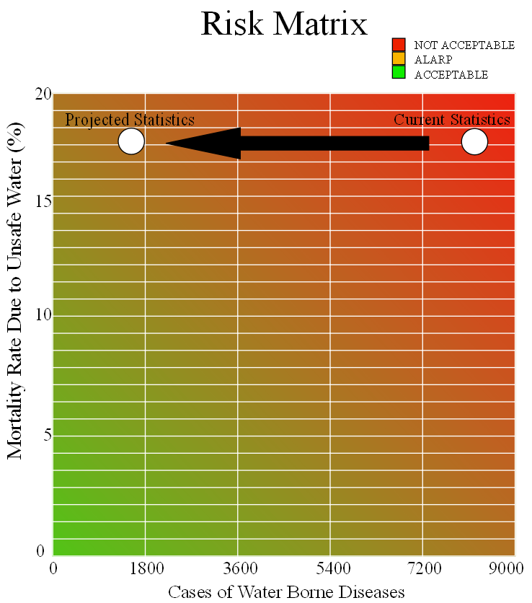

Figure 5: Risk Matrix

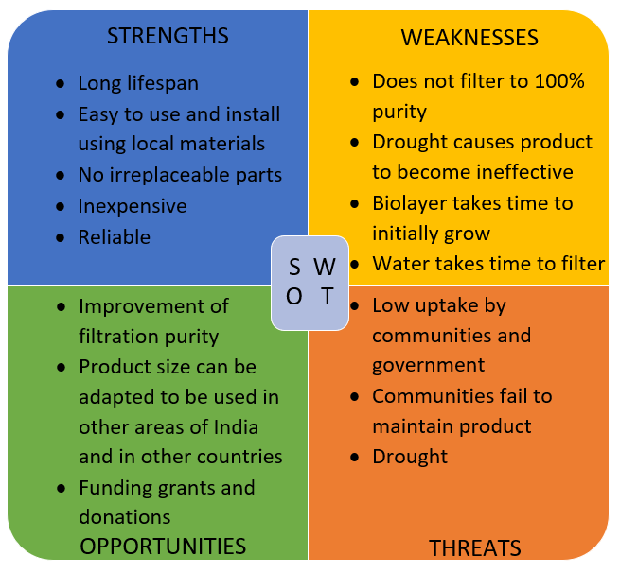Following on from the previous Risk Matrix, this highlights the importance of not misleading the locals with regards to their safety. It will need to be clearly explained to them and any organisation involved with the projects funding that the filter is not 100% effective but that it is the best available solution with a focus on being self-sustainable for maintenance and general upkeep. The filter can be easily maintained by a local who would need to replace come layers of sediment and regularly remove a layer of ‘slime’ and organic matter that can build up on top of the filter. The region of Tamil Nadu is prone to getting up to 6 cyclones a year, this can be devastating for rural communities who can often be cut off from aid due to being so isolated. Since the filter is self-sufficient it allows the local communities to continue to receive clean drinking water in a crisis. This project does not aim to make any profit from the locals or the government and any money made that is not needed to cover the construction of the filters will be used to make improvements on the filtration systems in terms of removing more contaminants or having a higher flow rate through the filter to provide more drinking water in a shorter space of time.

Figure 6: SWOT Diagram

**Prospective Design Improvements**

With every project and aspect in life, there is always room for improvement and advancement. There are several disadvantages with a slow sand filter, the main one being that the rate of filtration is very low. Hence, a great time scale is required to output a large volume of filtrated water.

Therefore, the main improvement for the project could be to reduce the time required to purify the water. One such improvement could be to use rapid sand filters rather than slow sand filters. However, rapid sand filters are far more expensive and have more complicated systems. Moreover, this would require government subsidies or additional funding in order further advance the project in this direction.

With more research into filter designs, the filter could be altered or improved upon to filter out more harmful materials from the water, making it more effective at reducing disease. This would likely require a considerable increase in the cost of producing each individual filter and may not be cost effective.

Future work for the project could be providing each home with an individual slow sand filter, rather than the slow sand filter being shared between several homes. If the project proves to be successful within 3 years, this would be a very achievable target for the project.

**Conclusion**

The 2018-19 Engineers Without Border Engineering for People Design Challenge asked for entries to propose engineering innovations and interventions to make a difference to people’s quality of life in Tamil Nadu, India. Due to a large proportion of Tamil Nadu’s roughly 37 million people living in rural areas rely on unmanaged, poor quality sources of groundwater, we proposed the usage of a slow sand filter, utilising river water and rain to provide a sustainable source of clean drinking water. Our project is able to provide each person with 55 litres of clean drinking water for 10 years for only £15 each, hence making it a very affordable and effective solution.

# **References**

|  |  |
| --- | --- |
| [1] | Census 2011, "Tamil Nadu Population Census data 2011," Census 2011, 2011. [Online]. Available: https://www.census2011.co.in/census/state/tamil+nadu.html. [Accessed 9 November 2018]. |
| [2] | Engineers Without Borders, "Engineering for People Design Challenge 2018-2019 Challenge," 2018. [Online]. Available: https://www.ewb-uk.org/engineering-for-people/2018-19-challenge/. [Accessed 29 October 2018]. |
| [3] | Centre for Affordable Water and Sanitation Technology, "FAQ: How much does a HydrAid filter cost? | Household Water Treatment and Safe Storage Knowledge Base," [Online]. Available: https://www.hwts.info/faq/5ff9f4cb/how-much-does-a-hydraid-filter-cost. [Accessed 12 November 2018]. |
| [4] | Centers for Disease Control and Prevention, "Slow Sand Filtration," [Online]. Available: https://www.cdc.gov/safewater/sand-filtration.html. [Accessed 12 November 2018]. |
| [5] | TamilNadu Water Supply and Drainage Board, "TAMILNADU WATER SUPPLY AND DRAINAGE BOARD," [Online]. Available: http://www.twadboard.gov.in/twad/ruwater_supply.aspx?fbclid=IwAR2tBVhy1KEnhiPsG9MiZBOBYsjWksNGzaD_PQKgi7lgKsITfKu0SPA8y20. [Accessed 12 November 2018]. |
| [6] | Rex Plastics, "How Much Do Injection Molds Cost?," 15 July 2013. [Online]. Available: https://rexplastics.com/plastic-injection-molds/how-much-do-plastic-injection-molds-cost. [Accessed 12 November 2018]. |
| [7] | TamilNadu Water Supply and Drainage Board, "TAMILNADU WATER SUPPLY AND DRAINAGE BOARD," [Online]. Available: http://www.twadboard.gov.in/twad/tariff.aspx?fbclid=IwAR3CAjbXzqakQotgfDj6xOFzJ2IJfcw5s1beGu2qyyXDAGuAKfn37mRvsuo. [Accessed 12 November 2018]. |
| [8] | World Bank, "India: Bringing Clean Drinking Water To India's Villages," 24 May 2016. [Online]. Available: http://www.worldbank.org/en/results/2016/05/24/bringing-clean-water-india-villages?fbclid=IwAR2JiqOqYe6jsEaJFoPifnGHOlqRpesUdUWXnkXzqdHsCREIjgoCSjFrJT0. [Accessed 12 November 2018]. |
| [9] | Kickstarter, "Kickstarter Stats - Kickstarter," [Online]. Available: https://www.kickstarter.com/help/stats. [Accessed 12 November 2018]. |
| [10] | T. Shah, "Where India's water economy stands," 2015. [Online]. Available: https://www.downtoearth.org.in/news/where-indias-water-economy-stands-40653?fbclid=IwAR0k4LevxBQIjnbU97JIBgKV2A6YduzQwaSWL-BjStmgmLagh7kl5_KtKE8. [Accessed 5 November 2018]. |
| [11] | I. S. (Specious), "File:2008-09-20 Dirty water spilling from a bottle.jpg," 2 September 2008. [Online]. Available: https://commons.wikimedia.org/wiki/File:2008-09-20_Dirty_water_spilling_from_a_bottle.jpg. [Accessed 9 November 2018]. |
| [12] | R. sikar, "File:Chaupal Birodi Chhoti.JPG," 12 January 2006. [Online]. Available: https://commons.wikimedia.org/wiki/File:Chaupal_Birodi_Chhoti.JPG. [Accessed 9 November 2018]. |
| [13] | Financing Sustainable Water, "Fiscal Sustainability," [Online]. Available: https://www.financingsustainablewater.org/fiscal-sustainability. [Accessed 12 November 2018]. |
| [14] | DFID - UK Department for International Development, "File:Providing clean water to millions of people.jpg," 14 August 2011. [Online]. Available: https://commons.wikimedia.org/wiki/File:Providing_clean_water_to_millions_of_people.jpg. [Accessed 28 November 2018]. |

**Appendix I: Plan of Work**



Figure 7: Gantt Chart detailing the plan of work

**Appendix II: Minutes**

**Minutes of Meeting 1 of Group Meeting – 25/09/18**

**Present:** Alex Swift, Andrew Hannigan, Blair McGilvray, Bethany Mulliner, Musaab Mohamed, Lara Severne, Duncan Fraser

**Apologies:**

**Not Present:**

Minutes taken by:

|  |  |  |
| --- | --- | --- |
| **No.** | **ITEM** | **ACTION** |
| **1.** | **Plan for meeting:** Decide on suitable days and times for forthcoming meetings. |  |
| **2.** | Supervisor meeting every Tuesday at 14:15  Meeting without supervisors every Thursday at 13:15 |  |
| **3.** | **Plan for next meeting:** Decide on research topics for every group member |  |
| **4.** | **Date of Next Meeting:** 27/09/18  **Time:** 13:15  **Place:** JW Study Area  **Chair:** Bethany Mulliner **Minute Taker:** Blair McGilvray |  |

**Minutes of Meeting 2 of Group Meeting – 27/09/18**

**Present:** Alex Swift, Andrew Hannigan, Blair McGilvray, Bethany Mulliner, Musaab Mohamed

**Apologies:**

**Not Present:**

Minutes taken by: Blair McGilvray

|  |  |  |
| --- | --- | --- |
| **No.** | **ITEM** | **ACTION** |
| **1.** | **Plan for meeting:** Every member of the group to choose a topic to research. |  |
| **2.** | Alex: Waste  Andrew: Sanitation  Blair: Digital  Bethany: Water  Musaab: Energy |  |
| **3.** | **Plan for next meeting:** Finalise a plan to go ahead with from the topic research. |  |
| **4.** | **Date of Next Meeting:** 02/10/18  **Time:** 14:15  **Place:** JW Study Area  **Chair:** Bethany Mulliner **Minute Taker:** Blair McGilvray |  |

**Minutes of Meeting 3 of Group Meeting – 02/10/18**

**Present:** Alex Swift, Blair McGilvray, Bethany Mulliner, Musaab Mohamed, Lara Severne, Duncan Fraser

**Apologies:** Andrew Hannigan; explained that he had a lab.

**Not Present:**

Minutes taken by: Blair McGilvray

|  |  |  |
| --- | --- | --- |
| **No.** | **ITEM** | **ACTION** |
| **1.** | **Plan for meeting:** Every group member to go over the research that they have done for the meeting. |  |
| **2.** | **Plan for next meeting:** Group members to do further research so that a preliminary topic can be chosen. |  |
| **3.** | **Date of Next Meeting:** 04/10/18  **Time:** 13:15  **Place:** JW Study Area  **Chair:** Bethany Mulliner **Minute Taker:** Blair McGilvray |  |

**Minutes of Meeting 4 of Group Meeting – 04/10/18**

**Present:** Alex Swift, Andrew Hannigan, Blair McGilvray, Bethany Mulliner, Musaab Mohamed

**Apologies:**

**Not Present:**

Minutes taken by: Blair McGilvray

|  |  |  |
| --- | --- | --- |
| **No.** | **ITEM** | **ACTION** |
| **1.** | **Plan for Meeting:** Look over group member’s topic research and choose a topic. |  |
| **2.** | The topic chosen was water. The idea which was chosen was Andrew’s Slow Sand Filter. |  |
| **3.** | **Plan for next meeting:** Each member to do individual research into the Slow Sand Filter. |  |
| **4.** | **Date of Next Meeting:** 09/10/18  **Time:** 14:15  **Place:** JW Study Area  **Chair:** Bethany Mulliner **Minute Taker:** Blair McGilvray |  |

**Minutes of Meeting 5 of Group Meeting – 09/10/18**

**Present:** Alex Swift, Andrew Hannigan, Blair McGilvray, Bethany Mulliner, Musaab Mohamed, Lara Severne, Duncan Fraser

**Apologies:**

**Not Present:**

Minutes taken by: Blair McGilvray

|  |  |  |
| --- | --- | --- |
| **No.** | **ITEM** | **ACTION** |
| **1.** | **Plan for meeting:** Each member to go over the research carried out on the Slow Sand Filter. |  |
| **2.** | Discussed the idea with the supervisors and got feedback on what they thought of the idea. It was decided that this would be the final idea and plan to go ahead with. |  |
| **3.** | **Plan for next meeting:** Continuing research into the Slow Sand Filter and building a profile of the idea. |  |
| **4.** | **Date of Next Meeting:** 11/10/18  **Time:** 13:15  **Place:** JW Study Area  **Chair:** Bethany Mulliner **Minute Taker:** Blair McGilvray |  |

**Minutes of Meeting 6 of Group Meeting – 11/10/18**

**Present:** Alex Swift, Andrew Hannigan, Blair McGilvray, Musaab Mohamed

**Apologies:** Bethany Mulliner, explained that he had a meeting to go to.

**Not Present:**

Minutes taken by: Blair McGilvray

|  |  |  |
| --- | --- | --- |
| **No.** | **ITEM** | **ACTION** |
| **1.** | **Plan for meeting:** To look over the research on Slow Sand Filter done by each member. |  |
| **2.** | Looked over the research done and started to construct a plan for the project report. Each member was delegated a part of research to specify in. |  |
| **3.** | **Plan for next meeting:** Further research into each member’s specific topic of the project. |  |
| **6.** | **Date of Next Meeting:**16/10/18  **Time:** 14:15  **Place:** JW Study Area  **Chair:** Blair McGilvray **Minute Taker:** Blair McGilvray |  |

**Minutes of Meeting 7 of Group Meeting – 16/10/18**

**Present:** Alex Swift, Andrew Hannigan, Bethany Mulliner, Musaab Mohamed, Lara Severne, Duncan Fraser

**Apologies:** Blair McGilvray, meeting with personal tutor.

**Not Present:**

Minutes taken by: Bethany Mulliner

|  |  |  |
| --- | --- | --- |
| **No.** | **ITEM** | **ACTION** |
| **1.** | **Plan for meeting:** To discuss process of producing Slow Sand Filter. |  |
| **2.** | **Plan for next meeting:** Continuing research on slow sand filter. |  |
| **3.** | **Date of Next Meeting:**18/10/18  **Time:** 13:15  **Place:** JW Study Area  **Chair:** Bethany Mulliner **Minute Taker:** Bethany Mulliner |  |

**Minutes of Meeting 8 of Group Meeting – 18/10/18**

**Present:** Alex Swift, Andrew Hannigan, Bethany Mulliner, Musaab Mohamed

**Apologies:** Blair McGilvray, personal matter.

**Not Present:**

Minutes taken by: Bethany Mulliner

|  |  |  |
| --- | --- | --- |
| **No.** | **ITEM** | **ACTION** |
| **1.** | **Plan for meeting:** To go over the report and sections on which the members want to write. |  |
| **2.** | **Plan for next meeting:** Each member to do specific research sections for the report. |  |
| **3.** | **Date of Next Meeting:** 23/10/18  **Time:** 14:15  **Place:** JN Crush Area  **Chair:** Bethany Mulliner **Minute Taker:** Bethany Mulliner |  |

**Minutes of Meeting 9 of Group Meeting – 25/10/18**

**Present:** Alex Swift, Andrew Hannigan, Blair McGilvray, Bethany Mulliner, Musaab Mohamed

**Apologies:**

**Not Present:**

Minutes taken by: Blair McGilvray

|  |  |  |
| --- | --- | --- |
| **No.** | **ITEM** | **ACTION** |
| **1.** | **Plan for meeting:** Decide on topics for everyone to start for the report. |  |
| **2.** | Introduction – Bethany  Project overview – Bethany  Project itself – Blair  Costing and Funding – Alex  Economic outlook – Musaab  Safety and Environment – Andrew  Improvements and future work – Blair  Final overview/conclusions – Bethany |  |
| **3.** | **Date of Next Meeting:** 30/10/18  **Time:** 14:15  **Place:** JN Crush Area  **Chair:** Bethany Mulliner **Minute Taker:** Blair McGilvray |  |

**Minutes of Meeting 10 of Group Meeting – 30/10/18**

**Present:** Alex Swift, Andrew Hannigan, Blair McGilvray, Bethany Mulliner, Musaab Mohamed, Duncan Fraser

**Apologies:**

**Not Present:**

Minutes taken by: Blair McGilvray

|  |  |  |
| --- | --- | --- |
| **No.** | **ITEM** | **ACTION** |
| **1.** | **Plan for meeting**: Group members to go over what they have written for their sections. |  |
| **2.** | **Plan for next meeting:** Group members to have done some more writing on their chosen sections. |  |
| **3.** | **Date of Next Meeting:** 06/11/18  **Time:** 13:15  **Place:** JN Crush Area  **Chair:** Bethany Mulliner **Minute Taker:** Blair McGilvray |  |

**Minutes of Meeting 11 of Group Meeting – 06/11/18**

**Present:** Alex Swift, Andrew Hannigan, Blair McGilvray, Bethany Mulliner, Musaab Mohamed, Lara Severne, Duncan Fraser

**Apologies:**

**Not Present:**

Minutes taken by: Blair McGilvray

|  |  |  |
| --- | --- | --- |
| **No.** | **ITEM** | **ACTION** |
| **1.** | **Plan for meeting:** Going over the report with the supervisors. |  |
| **2.** | Supervisors went over the report with the group and gave feedback on would could be improved and changed. Discussed the poster and how to plan on designing it. |  |
| **3.** | **Date of Next Meeting:** 08/11/18  **Time:** 14:15  **Place:** JN Crush Area  **Chair:** Bethany Mulliner **Minute Taker:** Blair McGilvray |  |

**Minutes of Meeting 12 of Group Meeting – 08/11/18**

**Present:** Alex Swift, Andrew Hannigan, Blair McGilvray, Bethany Mulliner, Musaab Mohamed

**Apologies:**

**Not Present:**

Minutes taken by: Blair McGilvray

|  |  |  |
| --- | --- | --- |
| **No.** | **ITEM** | **ACTION** |
| **1.** | **Plan for meeting:** To go over the plan for the poster. |  |
| **2.** | **Plan for next meeting:** Design template for poster to be completed and have members relevant diagrams completed. |  |
| **3.** | **Date of Next Meeting:**13/11/18  **Time:** 14:15  **Place:** JN Crush Area  **Chair:** Bethany Mulliner **Minute Taker:** Blair McGilvray |  |

**Appendix III: Peer Review**

**Andrew Hannigan:**

The EWB project was a fantastic learning experience for me as it focused more on the soft skills needed to become an engineer such as keeping to deadlines and having good communication within the group. I feel our group worked very well together and moved the project closer to completion with each meeting. Even the best laid plans can snag and ours was no different, getting to grips with a new aspect of engineering was the biggest challenge to begin with. However, everyone was always willing to put extra effort towards meeting a deadline and helping each other out. I can’t fault anyone in this team for lack of commitment.

Overall I am satisfied with this course as it has allowed me to gain an understanding of different engineering disciplines; Robotics, Chemical and Electrical. Through these differences each member brought their own unique problem-solving methods which were used to great effect.

**Blair McGilvray:**

The EWB project was a fantastic opportunity to work with the other engineering disciplines which I had previously not had much contact with. The project itself was something different from the norm as it was heavily focused on the business and economics side of a project rather than the actual design of a product. I rather enjoyed working on a project that entailed content that I was not familiar with and it was a great challenge.

I thoroughly enjoyed working with my group on this project. I feel that everyone was committed right from the first meeting to create a project to a very high standard. The team worked extremely well together, and every member put in the necessary work required to complete the project. It was a great opportunity to utilise everyone's unique skill sets and use them to our best ability. Occasionally we did not always complete our tasks to the timeframe that we set, but we always managed to catch up and get back onto the right path.

Overall, I am satisfied with the course and the project that we completed. I enjoyed interacting with the other engineering disciplines and experiencing how they tackle problems and projects. I am very happy with the work that we completed and with overall performance of our group.

**Musaab Mohamed:**

I had a great experience with the EWB project. Through this project, I was able to see and learn skills that engineers encounter on a daily basis. Also, it amazed how as a group we were able to apply different thoughts and ideas into this project.

As a group we understood that each person has a different schedule, so we planned our meetings on days that work for everyone and would put down different ideas, then as a group, we would decide on which idea works best. Everyone was nice each other and was willing to help with what we can and our supervisors as well.

In other words, even though each one of us has a part to work on, we still helped each other. When we disagree on ideas, we always found a way to agree.

In conclusion, I am satisfied with this course because it allowed applying different techniques outside the Field of Engineering study. What I learned from the EWB would be very useful in practical life and especially the ability to identify problems and find solutions.

**Bethany Mulliner:**

In my opinion, the opportunity to take part in the Engineers without Borders was a welcome change to the dull monotony of more theoretical courses. The chance to apply learnt knowledge to something meaningful was a good motivator towards completing the project.

I very much enjoyed working on this project and leading my team. I felt that our team worked extremely well together to put in the necessary hard work to produce a good result. Every member of the team brought their own skills to the table, which we utilised to the greatest extent possible to produce the best possible result. Due to this, all of our tasks were completed on time and to a very high standard.

While I did feel that on occasion we fell behind the deadlines we had set, we recovered and got back on track rapidly. It never felt as if anyone wasn’t pulling their weight since everyone always had something new to share at each meeting. Our supervisors provided insightful and helpful support to us along the way, which aided us greatly in producing an excellent poster and report.

Whilst the course in general was very good, one slight disappointment came when our marker was several hours late to our poster presentation without any valid excuse or explanation by the department, which all members of our team found very disrespectful considering the amount of effort we had put into our poster.

Regardless of this, overall I feel very satisfied with the course, my performance and the performance of my colleagues, and I feel that we have created a piece of work that we should all be pleased with.

**Alex Swift:**

Taking part in EWB was a great experience for me, seeing where I could apply what I learned from other subjects with a definite goal was very satisfying.

The topics covered in the course were very interesting. I hadn’t previously learned much about economics, marketing, operations management, sustainability, ethics, or health and safety. It was also a very good opportunity to improve my researching skills, as well as expand my skills in other areas, particularly economics.

I feel our team worked very well together. It was always clear what the next step we needed to take was, and although we were occasionally a little behind on the work, we always caught up again quickly and stayed on track. People were late to or missing meeting several times, but generally the communication within the group meant everyone gave notice in advance when this happened, and any work done was passed on for the meeting so we always had everything we needed.

The work was challenging as a lot of the aspects were new to me, but I’m glad I got the opportunity to take part in it.

We met twice each week, once with our supervisors and once just between ourselves. This let us quickly get through any research or designing that was required, and the meetings were very productive.

Overall I am satisfied with the course. Everybody worked well together, we communicated well, and we all did our share in making both the poster and report.

**Appendix IV: Supervisor Review**

**Duncan Fraser:**

Duncan was very helpful in suggesting ideas in the initial stage of the project, encouraging us to focus into specific target area, and his constructive feedback in the later stages also provided a lot of assistance.



**Lara Severne:**

As a group we found that Lara was critical of our ideas and quick to suggest improvements which we could make, which we found was extremely helpful and allowed us to build upon our initial ideas and develop our project.



**Appendix V: Declaration**

**INTERNAL TEAM ASSESSMENT DECLARATION FORM**

***TO BE SUBMITTED WITH ASSIGNMENT***

In order to ensure that all team members have participated to the assignment, each must declare their level of contribution to the project. This is not based on number of tasks completed, but **more contribution to the team and completion of the assignment**.

Level of contribution will be allocated to the marks. For example, if all team members have contributed fully to the project then each member’s level of contribution will be 100% and all members will receive the full awarding marks gained. However, if one team member has only contributed 50% of project and this agreed by all team members, that team member will only receive 50% of the awarded marks gained, whilst other members will receive the full 100%. See example.

**Each team member must sign the form and this must be included in the appendix of the final project report.** It is up to the team to discuss and agree contribution, but if no agreement can be made, the team must contact Amos Haniff to arbitrate a meeting.

Group Number 55

|  |  |  |
| --- | --- | --- |
| Group member | Level of Contribution %) | Signed |
| Andrew Hannigan | 100 |  |
| Blair McGilvray | 100 |  |
| Musaab Mohamed | 100 |  |
| Bethany Mulliner | 100 |  |
| Alex Swift | 100 |  |

**Example.**

Alice Wonderland 100%

Reza Mohammadi 100%

Jo Campbell 10%

Assuming this Group is awarded 75% for the assignment, Alice & Reza will receive 75% towards our final mark, but Jo would only receive 7.5%